DESIGN AND ANALYSIS OF ALGORITHMS
23CSE211-AVL TREE
Name: Uppu .Manju Sri nath
Roll no : CH.SC.U4CSE24249

1)BALANCING BST
USING AVL ROTATIONS

CODE:

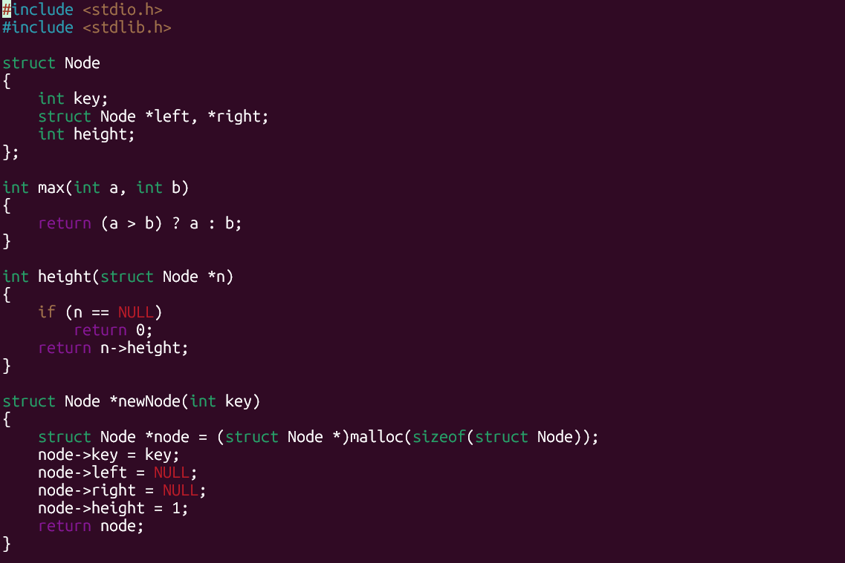
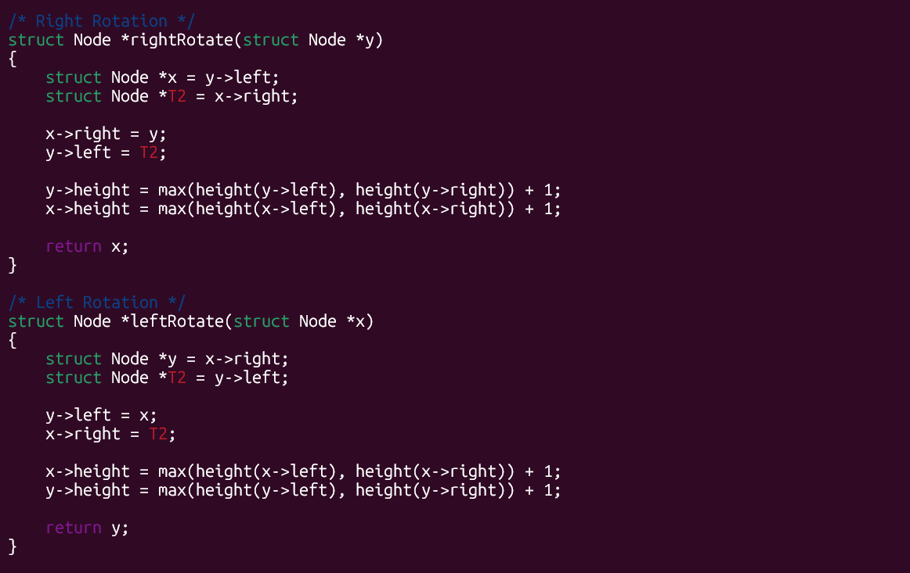
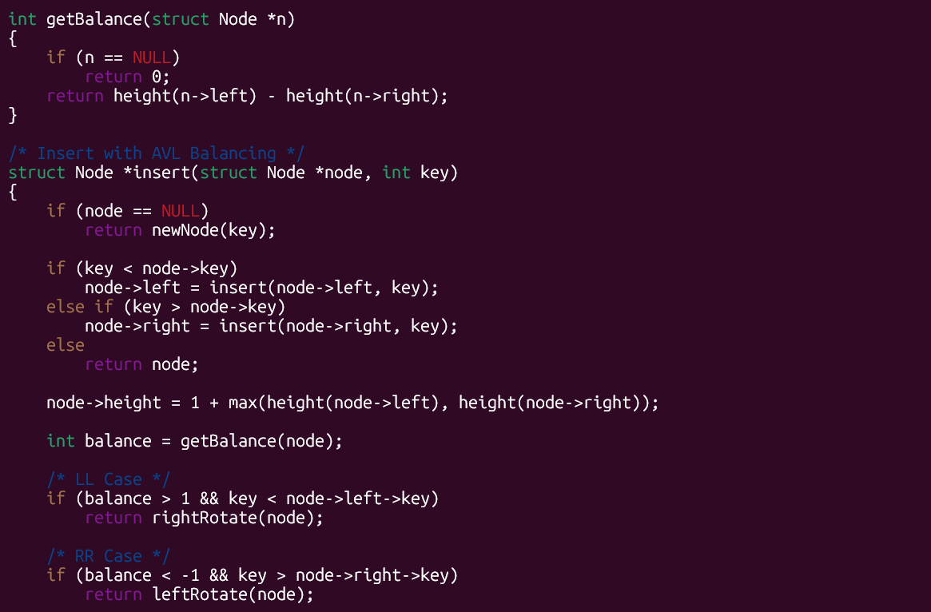
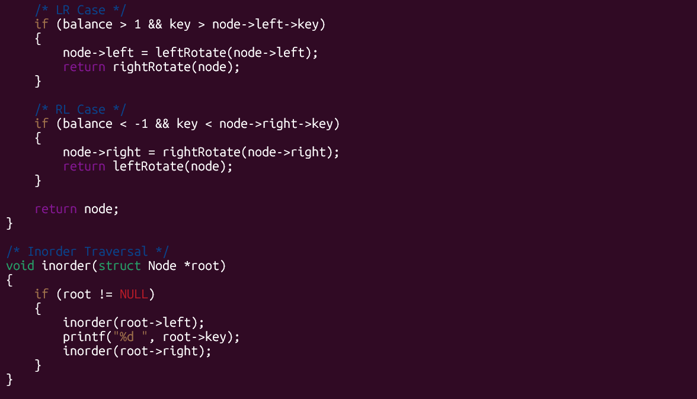
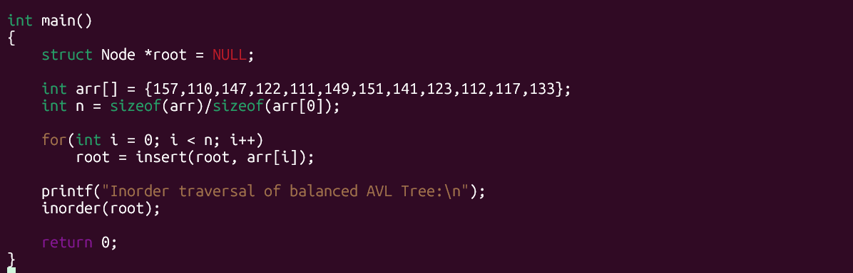

OUTPUT:

Time Complexity:
For your AVL program inserting
157, 110, 147, 122, 111, 149, 151, 141, 123, 112, 117, 133:
- Best Case: O(log n)
- Average Case: O(log n)
- Worst Case: O(log n)
Because after every insertion, AVL rotations keep the tree height balanced, so searching, inserting, and rotating always take logarithmic time.

Space Complexity:
- O(n) — space for storing n tree nodes
- O(log n) — extra stack space due to recursion (tree height)
So overall:
Space Complexity = O(n)

2)BALANCING BST
USING RED-BLACK TREE METHOD
CODE: 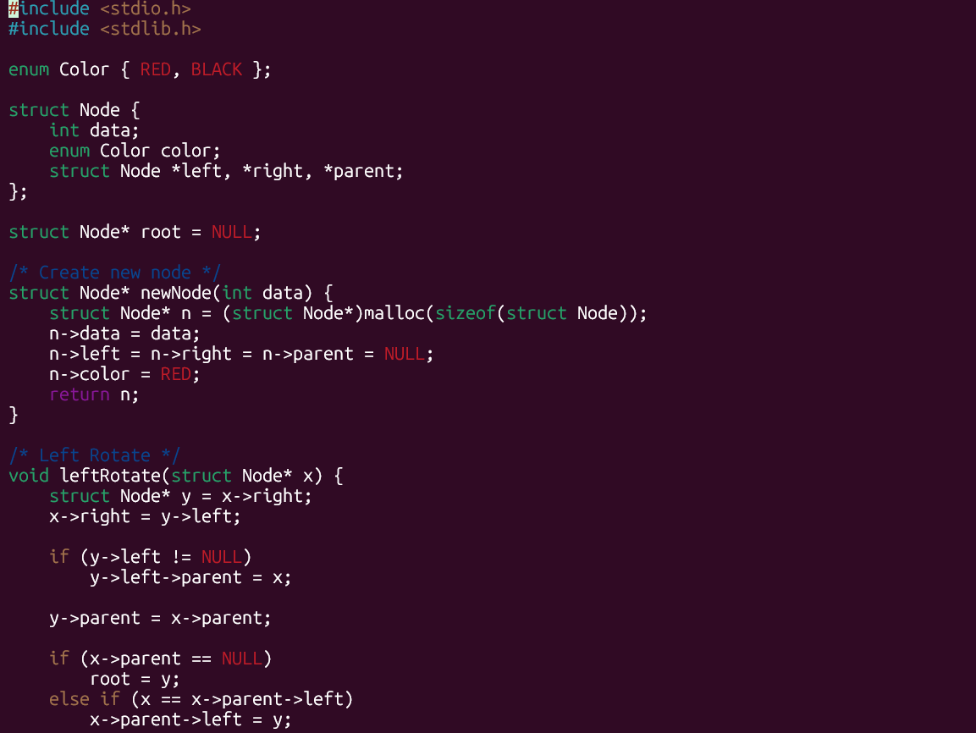
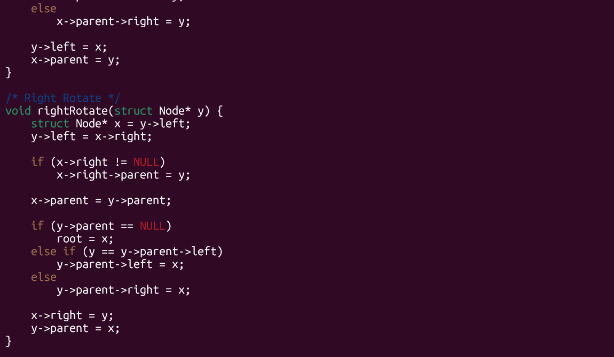
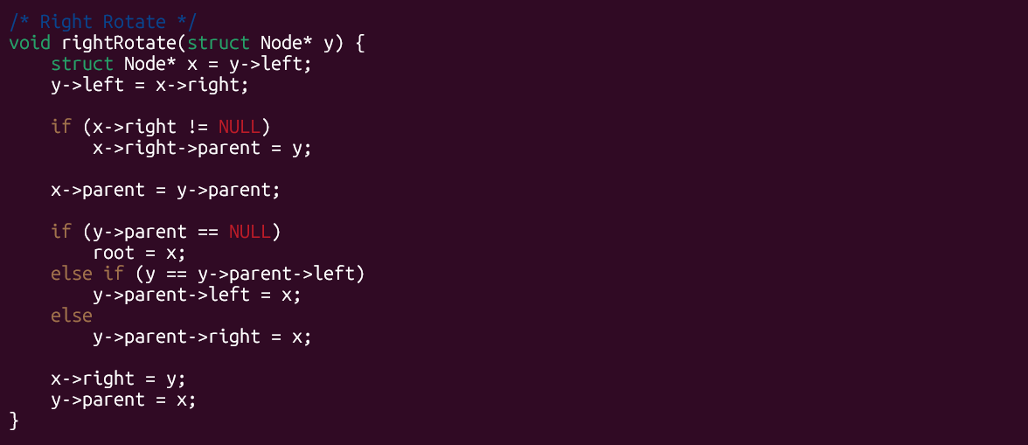
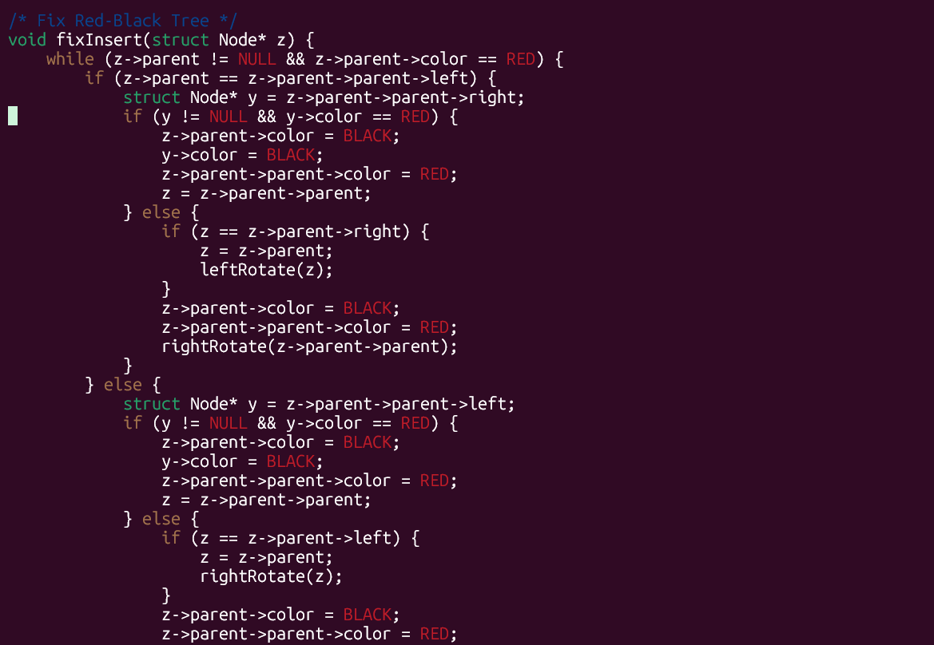
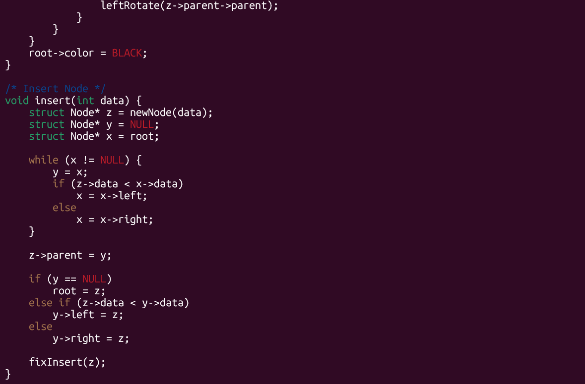
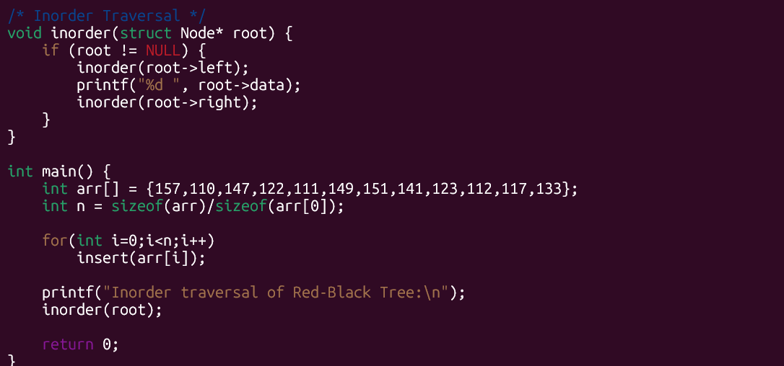

OUTPUT:
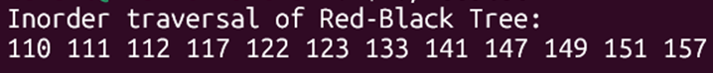

Time Complexity:
For your Red-Black Tree program inserting
157, 110, 147, 122, 111, 149, 151, 141, 123, 112, 117, 133:
- Best Case: O(log n)
- Average Case: O(log n)
- Worst Case: O(log n)
A Red-Black Tree always keeps its height O(log n) using node coloring and rotations, so search and insertion never become linear.
Space Complexity:
- O(n) → memory to store n nodes
- O(log n) → recursive calls (tree height) during traversal
So overall:
Space Complexity = O(n)

